**FRESH TEACHER'S E-LIBRARY**

**BEGINNING OF TERM III EXAMINATION 2023**

**TOP CLASS: (5 – 6 YEARS)**

**LEARNING AREA 3: HEALTH HABITS**

**My name is: ……………………………………………………………….**

**My School is: …………………………………….………………………..**

**I am in: ………………………………..…………………………….…………………..**

1. **Read draw these plants.**

|  |  |  |
| --- | --- | --- |
|  |  |  |
| banana plant | maize plant | yam plant |
|  |  |  |
| orange plant | mango plant | cassava plant |

1. **Name these dangerous objects.**

_______________

_______________

________________

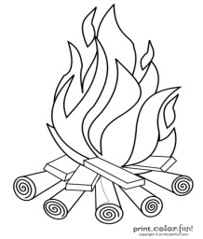

________________

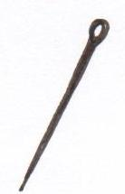

__________________

1. **Fill in the missing letters.**

ma ___g___ a___ ___le p__n___appl___

orang____ car___t yellowb___nan__

water me ____on

1. **Name these road signs.**

ears tasting

teeth hearing

hands seeing

eye touching

tongue chewing

1. **Colour correctly.**

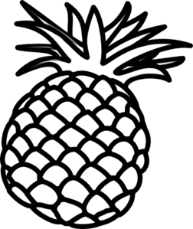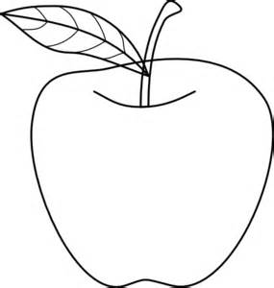

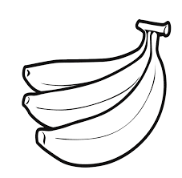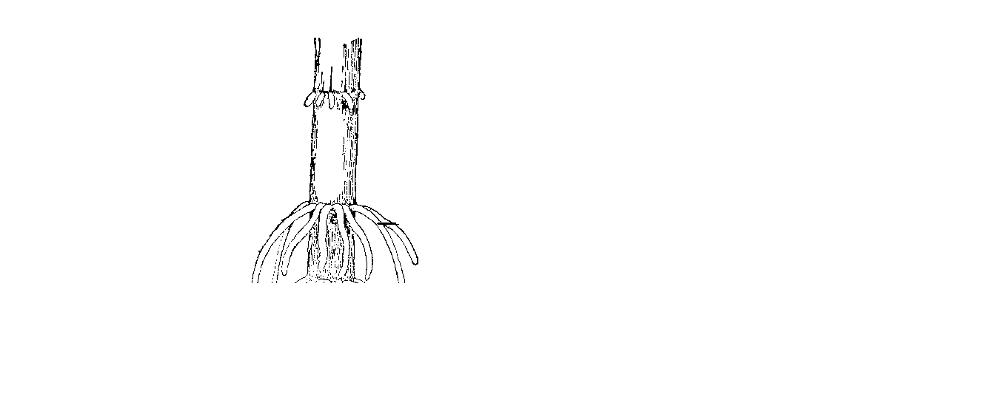

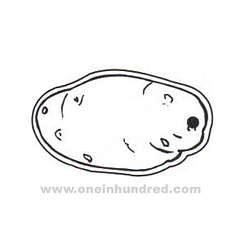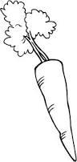

**End**